March 25, 2025

**Henkel Capital S.A. de C.V. Recalls Tec Italy Totale Shampoo Due to Potential Health Risk**

Rocky Hill, Connecticut

Henkel Capital S.A. de C.V. (“Henkel”) of Mexico is voluntarily recalling 1,068 units of its Tec Italy Shampoo Totale, as the product has the potential to be contaminated with *Klebsiella oxytoca*. Exposure to these bacteria can cause infections in humans, including infection in the eyes, nose and skin, with additional reactions for consumers with immune-compromised conditions.

The shampoo was distributed in the United States through distributors in New York and California. The shampoo may have been further distributed to other states. It was also sold to consumers at the retail level.

The recalled Tec Italy brand Totale Shampoo is packaged in a 33.81 fl. oz./1 L, green plastic bottle marked with Lot # 1G27542266 on the side of the bottle. The UPC code is 7501438375850.

The potential for product contamination was noted after microbiological analyses performed by the company revealed the presence of these bacteria in some of its 33.81 fl. oz./ 1 L bottles of Tec Italy Shampoo Totale.

To date, there have been no reports of user harm or injury related to these products. Consumers who experience symptoms, or have any medical questions associated with this recall, should consult a physician immediately.

Consumers who have purchased the applicable 33.81 fl. oz./1 L bottles of Tec Italy Shampoo Totale should stop using the product and return the products to their place of purchase for a full refund.

Tec Italy seeks to minimize all inconvenience this may cause consumers and are committed to their complete satisfaction. Questions may be directed to Tec Italy’s dedicated customer specialists at [sacli@henkel.com](mailto:sacli@henkel.com).

Henkel is conducting this recall with the knowledge of the U.S. Food and Drug Administration. Pictures of the recalled product are below.

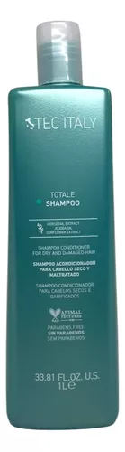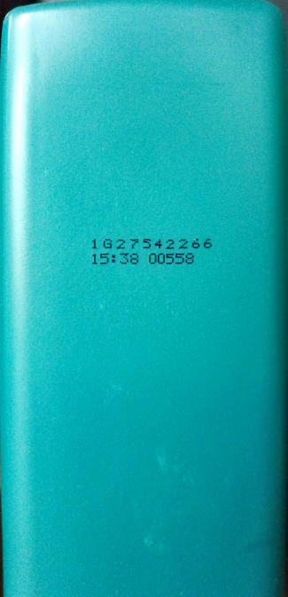

**About Henkel in North America**

Henkel’s portfolio of well-known brands in North America includes Schwarzkopf® hair care, Dial® soaps, Persil®, Purex®, and all® laundry detergents, Snuggle® fabric softeners as well as Loctite®, Technomelt® and Bonderite® adhesives. With sales close to 6.5 billion US dollars (6 billion euros) in 2024, North America accounts for 28 percent of the company’s global sales. Henkel employs around 8,000 people across the U.S., Canada and Puerto Rico. For more information, please visit [www.henkel-northamerica.com](http://www.henkel-northamerica.com) and on Twitter [@Henkel_NA](https://twitter.com/Henkel_NA).

**About Henkel**

With its brands, innovations and technologies, Henkel holds leading market positions worldwide in the industrial and consumer businesses. The business unit Adhesive Technologies is the global leader in the market for adhesives, sealants and functional coatings. With Consumer Brands, the company holds leading positions especially in laundry & home care and hair in many markets and categories around the world. The company's three strongest brands are Loctite, Persil and Schwarzkopf. In fiscal 2024, Henkel reported sales of more than 21.6 billion euros and adjusted operating profit of around 3.1 billion euros. Henkel’s preferred shares are listed in the German stock index DAX. Sustainability has a long tradition at Henkel, and the company has a clear sustainability strategy with specific targets. Henkel was founded in 1876 and today employs a diverse team of about 47,000 people worldwide – united by a strong corporate culture, shared values and a common purpose: "Pioneers at heart for the good of generations.” More information at [www.henkel.com](http://www.henkel.com).

**Photo material is available at** [**www.henkel-northamerica.com/press**](http://www.henkel-northamerica.com/press)

Media Contact:

Jennifer Schiavone

[Jennifer.schiavone@henkel.com](mailto:Jennifer.schiavone@henkel.com)

+1-475-299-9192

###