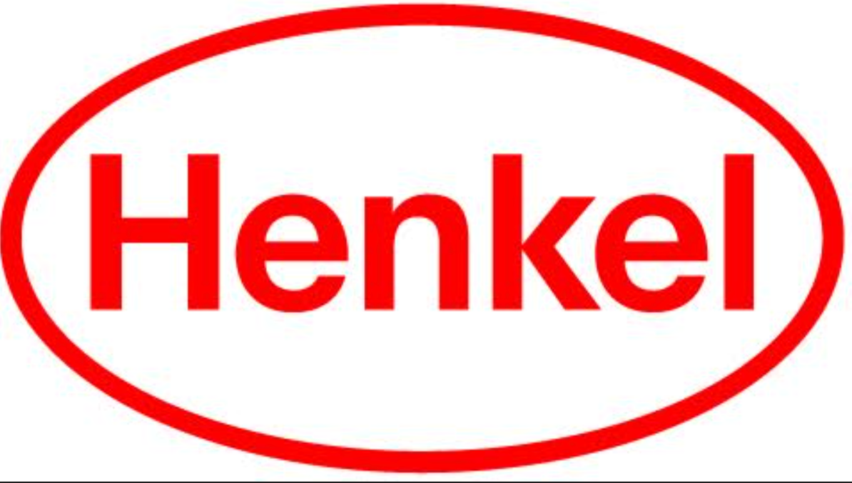

# Press Release

November 15, 2024

**Henkel ranks among top employers in Canada**

**Henkel Recognized as one of Canada’s Top 100**

**Employers**

Mississauga, Canada

Henkel, a leading manufacturer of well-known consumer and industrial brands, such as Dial® soap, Schwarzkopf® hair care, all® laundry detergent, and Loctite®, Technomelt® and Bonderite® adhesives, sealants, and functional coatings announced the company was named as one of [Canada’s Top 100 Employers](https://www.theglobeandmail.com/business/adv/article-canadas-top-100-employers-2024-winners/). Henkel also distributes Sunlight® laundry detergent – a brand trusted by Canadians for over 100 years.

Celebrating its 25th year, this annual award recognizes employers across Canada that create exceptional workplace environments that include premium health, financial, and family benefits, leadership and skills development, and innovative initiatives to attract and retain talented employees.

“This recognition is a testament to our passionate team of pioneers who consistently make a positive impact for Henkel, our customers and our communities,” said Robert Bertok, President, Henkel Canada. “Every day in my 36 years with the company, I come to work with pride and enthusiasm because of the creative, collaborative, and inspiring colleagues at Henkel. My heartfelt thanks to our entire team for helping to build a culture of belonging so everyone can bring their whole selves to work and achieve their full potential,”

Earning this honour reflects the company's commitment to creating a workplace where everyone feels included, valued and empowered. Henkel believes in investing in programs and resources to support employees in their career development journey and to care for their health and well-being. [Click here](https://reviews.canadastop100.com/top-employer-henkel-canada) to read more on why Henkel was selected.

**About Henkel in North America**Henkel’s portfolio of well-known brands in North America includes Schwarzkopf® hair care, Dial® soaps, Persil®, Purex®, and all® laundry detergents, Snuggle® fabric softeners as well as Loctite®, Technomelt® and Bonderite® adhesives, sealants and functional coatings. With sales close to 6.6 billion US dollars (6 billion euros) in 2023, North America accounts for 28 percent of the company’s global sales. Henkel employs around 8,000 people across the U.S., Canada and Puerto Rico. For more information, please visit [www.henkel-northamerica.com](http://www.henkel-northamerica.com/) and on Twitter [@Henkel_NA](https://twitter.com/Henkel_NA).  
  
  
**Henkel North America Contact:**  
Erica Cooper  
Phone: 475-232-4973  
Email: [erica.cooper@henkel.com](mailto:erica.cooper@henkel.com)