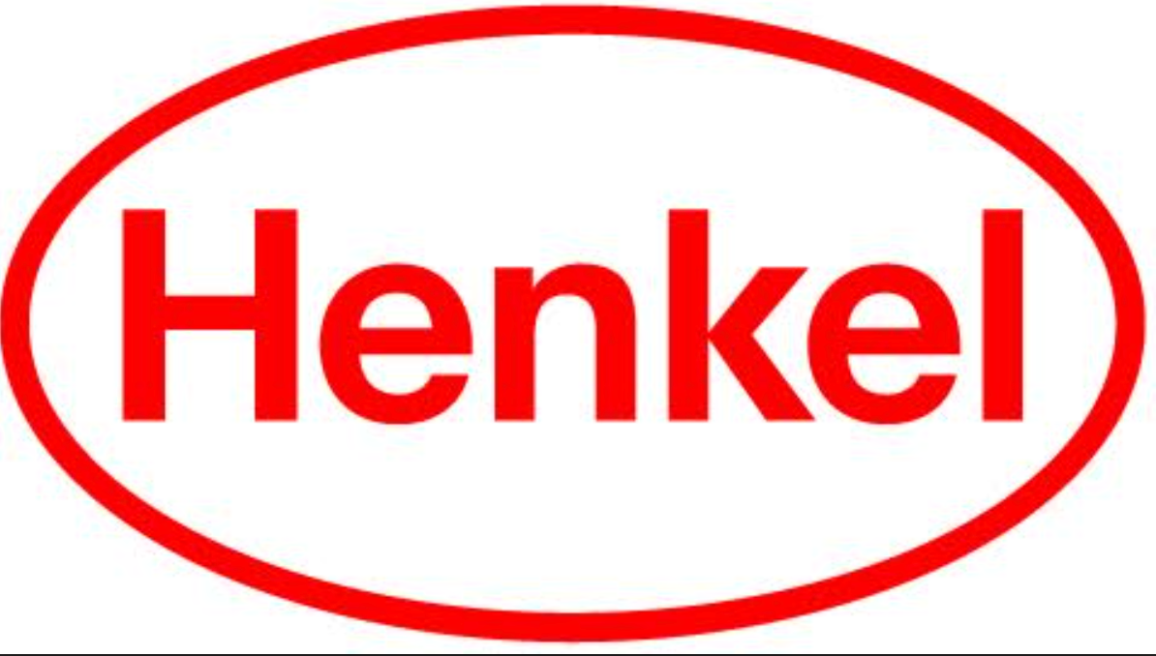

# Press Release

September 24, 2024

Henkel has been selected as a 2024 Safer Choice Partner of the Year, through their all® free clear and all® sensitive fresh liquid laundry detergent products.

**Henkel named 2024 Safer Choice Partner of the Year award winner**

Stamford, CT

Henkel has been named a 2024 Safer Choice Partner of the Year award winner through their all® free clear and all® sensitive fresh liquid laundry detergent products. Products with the Safer Choice label help consumers find products that work well and are certified by the Safer Choice program to contain safer ingredients for families and the environment.

The Safer Choice Partner of the Year Awards recognize the contributions of Safer Choice partners and stakeholders who have shown outstanding achievement in the design, manufacture, selection and use of innovative products with safer ingredients.

The all® free clear range of laundry detergent products are the #1 doctor recommended laundry brand for sensitive skin*, and this Safer Choice recognition helps further strengthen the confidence of the medical community to recommend it to their patients. Instead of just removing dyes and perfumes, all® free clear brand’s formula is built from the ground up, ensuring that every ingredient is chosen both for effectiveness and gentleness on skin.

“We’re proud to be recognized as an EPA 2024 Safer Choice Partner of the Year award

winner,” said Martina Spinatsch, Senior Vice President, Research & Development, Henkel Consumer Brands, North America. “This award reflects our commitment to develop products that are safer for people and the planet. We believe that this is where our all® free clear purpose comes together with Safer Choice. It all starts with choosing safer ingredients.”

To qualify for the [Safer Choice label](https://www.epa.gov/saferchoice), a product must meet EPA’s Safer Choice Standard, which

includes stringent human and environmental health criteria. The Safer Choice program currently

partners with about 350 formulator-manufacturer partners who make nearly 2,000 Safer Choice certified products for both consumers and commercial buyers.

*\*Recommended by dermatologists, allergists and pediatricians for sensitive skin*

**About Henkel in North America**Henkel’s portfolio of well-known brands in North America includes Schwarzkopf® hair care, Dial® soaps, Persil®, Purex®, and all® laundry detergents, Snuggle® fabric softeners as well as Loctite®, Technomelt® and Bonderite® adhesives. With sales close to 6.6 billion US dollars (6 billion euros) in 2023, North America accounts for 28 percent of the company’s global sales. Henkel employs around 8,000 people across the U.S., Canada and Puerto Rico. For more information, please visit [www.henkel-northamerica.com](http://www.henkel-northamerica.com/) and on Twitter [@Henkel_NA](https://twitter.com/Henkel_NA).  
  
**Photo material is available at** [**www.henkel-northamerica.com/press**](http://www.henkel-northamerica.com/press)  
  
**Henkel North America Contact:**  
Erica Cooper  
Phone: 475-232-4973  
Email: [erica.cooper@henkel.c](mailto:erica.cooper@henkel.com)om